NGO CONG THANH

SWinburne university

Assignment 2

Overall Description of Project

My assembly programming project uses Raspberry Pi 3B+ to modify the LEDs flashing in fixed ways. In this project, I have included three individual LEDs in individual colors and using loop structure to adjust the flash pattern for the LEDs.

Because the limitations of device and chance to interact with the helpers, I decide to use a simulate software to do this assignment. It’s called Professional Proteus 8, which let us simulate a Raspberry Pi. The reason further I will tell you later in the Obstacle and Limitations part.

**Assignment 2 video link:**

**Fail practical video:** <https://drive.google.com/file/d/1bAzIQFwX3tj8Om1KNKsr0R6_zv1uA_aJ/view?usp=sharing>

**Proteus 8 video:**

<https://drive.google.com/file/d/1HgQkTBaoCI-5g_DHhOPUWwNoyiHnmFY2/view?usp=sharing>

Table of Contents

Overall Description of Project 1

Overall Description of Implementation 3

Some complex things that I did 5

Obstacles and Limitations 5

A summary of all ARM assembly instructions 6

Image 7

# Overall Description of Implementation

Three LEDs in different colors have been linked to its GPIO. When the program run, it will cause the LEDs flash in arrangement. It will make a loop that each LED will light up follow the previous LEDs. Each time when the loop’s counters reaches 4, 3 LEDs wills toggle on at the same time for few second.

**GPIOsetup.asm:**

The function of 3 GPIO is defined so that they can send signal two the LEDs appropriately

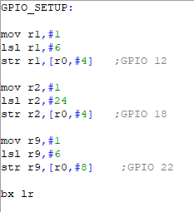

**Timer.asm**

Create a delay between events to make sure that it doesn’t indicate so fast.

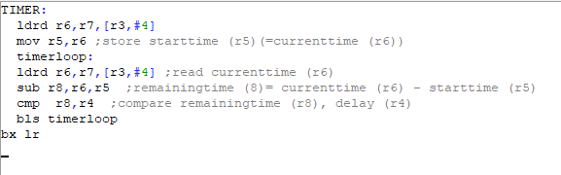

**Kernel7.asm:**

Where LEDs are controlled and modified the flash pattern. Constantly checking to see that a loop and a condition statement that I have applied to this assembly code.

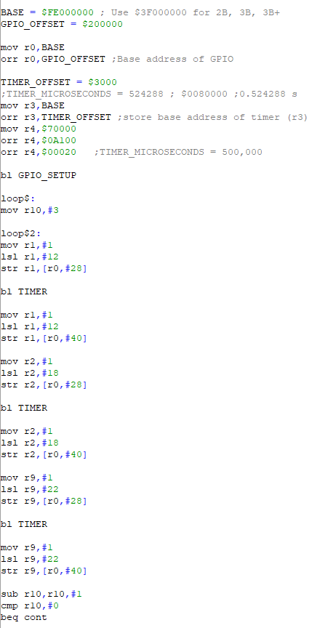

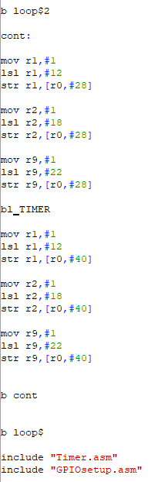

# Some complex things that I did

In this project, I have applies loop and condition statement to control the LED which take me couple of hours to figure and adjust.

# Obstacles and Limitations

Because of the pandemic, we have to learn from home. So it cause many difficult to communicate and finish this assignment. We only had few chance to work with Raspberry devices. Some student have a chance to go to campus and work directly with that device but some didn’t. I have to work with this assignment in a place where over 300km away from campus is. Moreover, I didn’t have a chance to work properly with Raspberry Pi so it took a lot of time to fixed and implementing the assembly code. When I talk to my friends who also are my helpers in this project, there are some misunderstanding between us in the only lab time for this assignment, so I cannot finish the assignment in time. I decide to use simulate software Professional Proteus 8 instead of real Raspberry Pi also because there are no Raspberry supplier near my place. I have spent couple of hours to work with this software and realized that it has practical benefits. However, this software doesn’t have some feature like Micro SD chip inserting or power but it work properly with Assembly programming language.

# A summary of all ARM assembly instructions

Start Infinite loop:

Move r10 to #3

Start loop$2:

Turn on LED1

Call Timer function

Turn off LED1

Turn on LED2

Call Timer function

Turn off LED2

Turn on LED3

Call Timer function

Turn off LED3

R10 = r10 - #1

Compare r10 with #0

If r10 = 0, go to cont function

End loop$2

End infinite loop

Cont function:

Turn on LED1

Turn on LED2

Turn on LED3

Call Timer function

Turn off LED1

Turn off LED2

Turn off LED3

End cont

# Image

